4) Create a visual representation in Figma highlighting the key elements of mobile network protocol stacks.
1. Aim
To create a visual representation in Figma highlighting the key elements of mobile network protocol stacks and illustrating how different protocol layers communicate in a mobile communication system.
2. Software Used
- Figma: For designing the visual representation.
- Google Chrome: For accessing Figma.
- Internet Connection: To create and save the design.
3. Procedure
- Open the Figma website (https://www.figma.com).
- Log in and create a new design file.
- Select the Frame tool to create a workspace.
- Add the title "Mobile Network Protocol Stacks".
- Create separate sections for different protocol layers.
- Use rectangles to represent each protocol layer.
- Arrange the layers in a proper hierarchical order.
- Use arrows to show communication between layers.
- Add labels, colors, and descriptions for each layer.
- Arrange all components neatly and save the design.
4. Prototype
The prototype represents the layered architecture of a mobile network protocol stack.
Key elements:
- Application Layer: Provides mobile applications and services.
- Transport Layer: Handles end-to-end data transmission using TCP and UDP.
- Network Layer: Manages IP addressing and packet routing.
- Data Link Layer: Provides reliable data transfer between connected devices.
- Physical Layer: Transmits data through radio signals.

5. Design
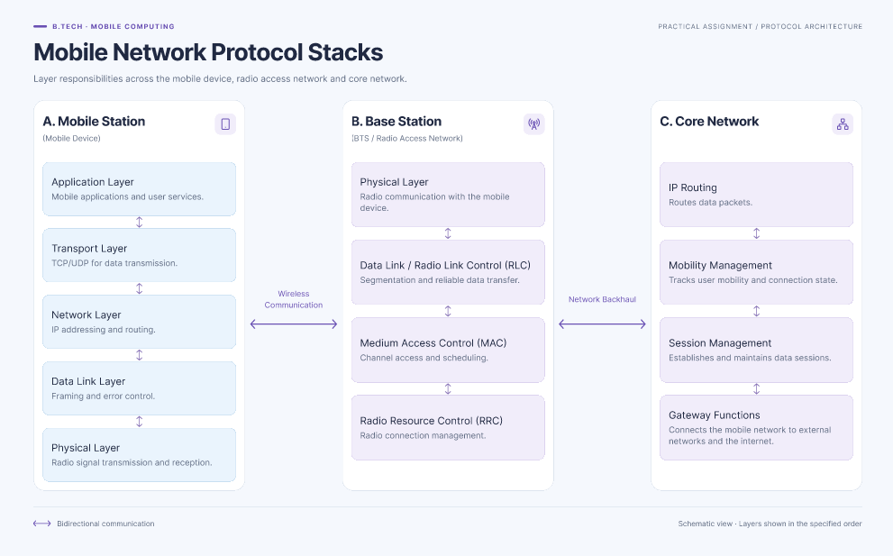

6. Result
Successfully created a visual representation of mobile network protocol stacks using Figma. The design highlights the Application, Transport, Network, Data Link, and Physical layers and explains their roles in mobile communication.

